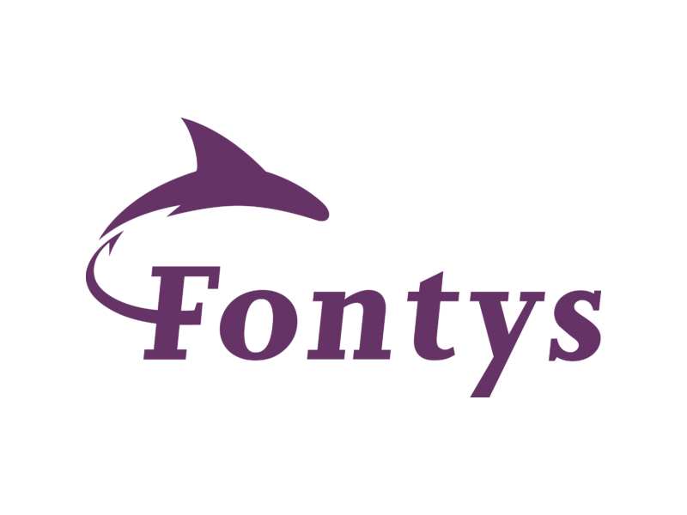

Test Report
Individual Project: Stream Sage
Date: 13-06-2024
Developer: Georgi Tinchev (g.tinchev@student.fontys.nl)
Tutor: Bhardwaj Sachin (sachin.bhardwaj@fontys.nl)

Table of Contents
- Test Cases + Test Results
- Recommendations for System Improvement

Test Cases + Test Results
Movie Management (FRD-1)
- Add Movie
  - ID: TC-MOV-01
  - Functional Requirement ID: FRD-1
  - Pre-condition: Administrator is logged in.
  - Test Steps:
    - Navigate to the "Add Movie" section of the admin dashboard.
    - Enter all required movie details (title, release date, description, poster image URL, trailer URL, runtime, average rating).
    - Click on the "Add Movie" button.
  - Expected Result: The movie should be successfully added to the database.
Result: The movie was added successfully without errors. Test case passed.
- Edit Movie
  - ID: TC-MOV-02
  - Functional Requirement ID: FRD-1
  - Pre-condition: Administrator is logged in.
  - Test Steps:
    - Navigate to the "Edit Movie" section of the admin dashboard.
    - Select an existing movie from the list.
    - Modify one or more details (title, description, runtime).
    - Save the changes.
  - Expected Result: The movie details should be updated in the database.
Result: The movie details were updated as expected. Test case passed.
- Delete Movie
  - ID: TC-MOV-03
  - Functional Requirement ID: FRD-1
  - Pre-condition: Administrator is logged in.
  - Test Steps:
    - Navigate to the "Delete Movie" section of the admin dashboard.
    - Select a movie to delete from the list.
    - Confirm the deletion action.
  - Expected Result: The selected movie should be permanently removed from the database.
Result: The movie was successfully deleted from the database. Test case passed.
User Management (FRD-2)
- User Registration
  - ID: TC-USER-01
  - Functional Requirement ID: FRD-2
  - Pre-condition: User attempts to register.
  - Test Steps:
    - Navigate to the registration page.
    - Fill out the registration form with valid details (username, email, password).
    - Submit the registration form.
  - Expected Result: The user should be registered and able to log in with the provided credentials.
Result: Registration was successful. User can now log in. Test case passed.
- User Login
  - ID: TC-USER-02
  - Functional Requirement ID: FRD-2
  - Pre-condition: User attempts to log in.
  - Test Steps:
    - Navigate to the login page.
    - Enter valid user credentials (username/email and password).
    - Click on the "Login" button.
  - Expected Result: The user should be authenticated and logged into the system.
Result: Login successful. User authenticated without issues. Test case passed.
- Update User Profile
  - ID: TC-USER-03
  - Functional Requirement ID: FRD-2
  - Pre-condition: User is logged in.
  - Test Steps:
    - Navigate to the user profile section.
    - Modify user profile information (e.g., update email address or change password).
    - Save the changes.
  - Expected Result: User profile should be updated with the new information.
Result: User profile updated successfully. Changes reflected in the system. Test case passed.
Genre, Actor, Director Management (FRD-3)
- Add Genre
  - ID: TC-GENRE-01
  - Functional Requirement ID: FRD-3
  - Pre-condition: Administrator is logged in.
  - Test Steps:
    - Navigate to the "Add Genre" section of the admin dashboard.
    - Enter genre details (name and description).
    - Click on the "Add Genre" button.
  - Expected Result: The new genre should be added to the genre list.
Result: Genre added successfully. Test case passed.
- Edit Genre
  - ID: TC-GENRE-02
  - Functional Requirement ID: FRD-3
  - Pre-condition: Administrator is logged in.
  - Test Steps:
    - Navigate to the "Edit Genre" section of the admin dashboard.
    - Select a genre from the list to edit.
    - Modify the genre details, such as updating the description.
    - Save the changes.
  - Expected Result: The genre details should be updated in the system.
Result: Genre edited successfully. Changes saved correctly. Test case passed.
- Delete Genre
  - ID: TC-GENRE-03
  - Functional Requirement ID: FRD-3
  - Pre-condition: Administrator is logged in.
  - Test Steps:
    - Navigate to the "Delete Genre" section of the admin dashboard.
    - Select a genre from the list to delete.
    - Confirm the deletion action.
  - Expected Result: The selected genre should be removed from the genre list.
Result: Genre deleted successfully. Test case passed.
- Add Actor
  - ID: TC-ACTOR-01
  - Functional Requirement ID: FRD-3
  - Pre-condition: Administrator is logged in.
  - Test Steps:
    - Navigate to the "Add Actor" section of the admin dashboard.
    - Enter actor details (name).
    - Click on the "Add Actor" button.
  - Expected Result: The new actor should be successfully added to the actor database.
Result: Actor added successfully. Test case passed.
- Edit Actor
  - ID: TC-ACTOR-02
  - Functional Requirement ID: FRD-3
  - Pre-condition: Administrator is logged in.
  - Test Steps:
    - Navigate to the "Edit Actor" section of the admin dashboard.
    - Select an actor from the list to edit.
    - Modify actor details, such as updating bio or image.
    - Save the changes.
  - Expected Result: Actor details should be updated with the new information.
Result: Actor edited successfully. Test case passed.
- Delete Actor
  - ID: TC-ACTOR-03
  - Functional Requirement ID: FRD-3
  - Pre-condition: Administrator is logged in.
  - Test Steps:
    - Navigate to the "Delete Actor" section of the admin dashboard.
    - Select an actor from the list to delete.
    - Confirm the deletion action.
  - Expected Result: The selected actor should be permanently deleted from the actor database.
Result: Actor deleted successfully. Test case passed.
- Add Director
  - ID: TC-DIRECTOR-01
  - Functional Requirement ID: FRD-3
  - Pre-condition: Administrator is logged in.
  - Test Steps:
    - Navigate to the "Add Director" section of the admin dashboard.
    - Enter director details (name, bio, image).
    - Click on the "Add Director" button.
  - Expected Result: The new director should be added to the director list.
Result: Director added successfully. Test case passed.
- Edit Director
  - ID: TC-DIRECTOR-02
  - Functional Requirement ID: FRD-3
  - Pre-condition: Administrator is logged in.
  - Test Steps:
    - Navigate to the "Edit Director" section of the admin dashboard.
    - Select a director from the list to edit.
    - Modify director details, such as updating bio or image.
    - Save the changes.
  - Expected Result: Director details should be updated in the system.
Result: Director edited successfully. Test case passed.
- Delete Director
  - ID: TC-DIRECTOR-03
  - Functional Requirement ID: FRD-3
  - Pre-condition: Administrator is logged in.
  - Test Steps:
    - Navigate to the "Delete Director" section of the admin dashboard.
    - Select a director from the list to delete.
    - Confirm the deletion action.
  - Expected Result: The selected director should be removed from the director list.
Result: Director deleted successfully. Test case passed.
User Authentication (FRD-4)
- User Authentication
  - ID: TC-AUTH-01
  - Functional Requirement ID: FRD-4
  - Pre-condition: User attempts to log in.
  - Test Steps:
    - Navigate to the login page.
    - Enter valid user credentials (username/email and password).
    - Click on the "Login" button.
  - Expected Result: The user should be authenticated and logged into the system.
Result: User authenticated successfully. Test case passed.
Interpretation Management (FRD-5)
- Submit Interpretation
  - ID: TC-INTERP-01
  - Functional Requirement ID: FRD-5
  - Pre-condition: User is logged in.
  - Test Steps:
    - Navigate to the "Submit Interpretation" section.
    - Enter interpretation content (text) and select the associated movie.
    - Click on the "Submit" button.
  - Expected Result: The interpretation should be successfully submitted and visible on the movie's page.
Result: Interpretation submitted successfully. Test case passed.
Review Management (FRD-6)
- Submit Review
  - ID: TC-REVIEW-01
  - Functional Requirement ID: FRD-6
  - Pre-condition: User is logged in.
  - Test Steps:
    - Navigate to the "Submit Review" section.
    - Enter review content (rating, text) and select the associated movie.
    - Click on the "Submit" button.
  - Expected Result: The review should be successfully submitted and visible on the movie's page.
Result: Review submitted successfully. Test case passed.

Recommendations for System Improvement
- Enhanced Error Handling
  - Implement more robust error handling mechanisms throughout the application to provide meaningful error messages to users and administrators.
- Performance Optimization
  - Conduct performance profiling and optimization because some of the queries and or different forms take a while to load up.
- Accessibility
  - Ensure the application meets accessibility standards (e.g., WCAG) to accommodate users with disabilities.
- Security Enhancements
  - Regularly review and update data, and ensure proper encapsulation is met all across the application.
- User Interface Refinements
  - Improve user interface design for better usability and intuitive navigation, especially for non-technical users.

